Logbook Week 10
March 24, 2026

On the tenth week we:
- Brought the linear slide parts and assembled the linear slide. The bar we ordered didn’t have threaded holes for the motor housing mount so we quickly did that and assembled it. We now have something physical to show for our first station:
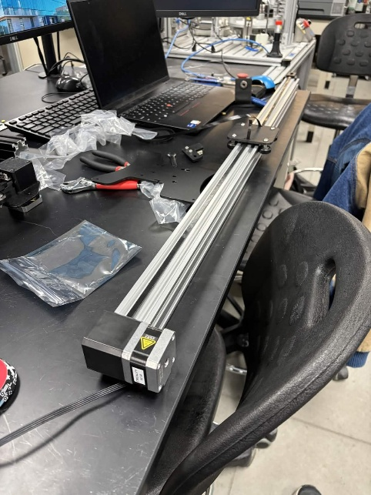
- We placed the housing with the motor and limit switch at one end and tied the belt. We have another limit switch mounted on a small piece. We ran into an issue on how we were going to mount this other limit switch to the other end. Jacob found out we can just attach the piece with nuts and bolts to the side of the bar and the wheel will hit the switch. It worked. Problem was solved quickly.
- We moved the robot, as we planned in the CAD. We found the correct Allen key and removed the bolts and moved the robot and placed them back in:
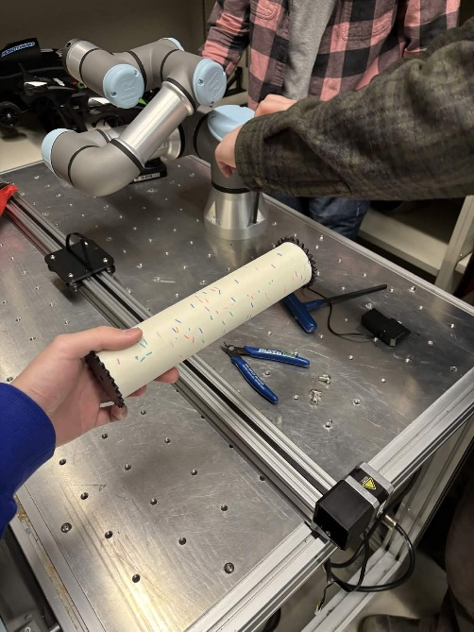
- Jamie also came up with a solution for one of our earlier issues and tested it. The roller pin shaft moves freely inside the roller, but we need it to be a fixed mate if we want a motor to drive it. So Jamie made some gears with a hole with a side (for the motor shaft) and made sure the gear inner diameter was tight enough to fit snugly into the roller ends, with the help of duct tape. It was pretty stable.
- We planned out our limit switch locations. Jacob found their datasheet with mounting specifications and dimensions and put it in our Google drive. We plan to have 6 in total. Two small ones at the end, which we already have as spare parts from the 3D printer, for the start and end of the batch sequence of the line. Then, 2 for stopping at the rice dispenser (1 for knowing it’s at the station, and 1 for knowing it reached the end of it, as the platform will move slowly forward for the rice to dispense evenly), 1 for stopping at the toppings dispenser, and 1 for stopping at the cutter, where it will roll first.
- We had a problem with bolting the linear slide to the table. The table hole is M8, but M8 bolts don’t fit in the groove of the rail. The Z nuts that fit into the groove of the rail are too tiny and just goes through the M8 table holes. We thought going with the bigger M8 bolt was better for stability, so we scrapped the Z nut option. We brainstormed a solution to bolt the slide with the M8 bolts. We spent a lot of the session thinking about options, such as 3D-printing our own custom bolts or even superglue and duct-tape (as a joke). We decided the best plan was to drill two non-threaded holes, 1 at each end of the rail, only at the bottom side. Then, with the head facing up, reach in with our fingers and place the M8 bolts down that hole and screw it with L Allen keys to the table. It could work. Just two tight bolts is probably enough to hold the whole rail stable on the table. The backup option is to drill holes straight from the top to the bottom of the whole rail and drop the M8 bolt into the hole from the top to the hole from the bottom, then screw it onto the table. But for now, the former thing is our plan.
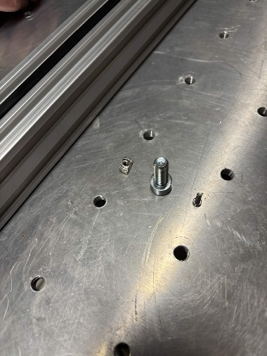

Things we will work on next week:
- Find crimps for the linear slide belt. Or just any piece we can use to ensure it is secured onto our platform and not loose. I suggested a Lego piece or something, or buying the standard ones from a 3D printer shop.
- Drill holes in our linear slide rail for the M8 bolts so we can bolt it to the table.
- Figure out how we’re going to mount the limit switches. I’m going to work on the CAD to space things out and see how these switches are going to be placed along the main linear rail for each substation. (continued from last week)
- Design the platform for the linear slide on CAD. Add a nib to it that will hit the limit switches as it passes through the slide. Add the necessary holes for bolting it to the roller wheels and for adding the ribcage roller platform that will rest on top of it. 3D print it. Assemble it. (continued from last week)
- Design the CAD for the ribcage roller.
- Work on the poster for the showcase in 2 weeks!

